Hello guys, please read carefully, and let me know if you can do it. This is a project for the university. The most part of the project is making. Now I need some changes who need my professor and also the project have some bugs. I need all the requirements and it is so important to working all correctly because I introduced the application and I take some comments. Only when I will finish the observations of the professors I will take my degree. The app is created for other freelancer but he doesn’t know how to create some things in the requirement below so I need more professional developers. So, let’s to start:

Information about the application: Abstract

The app is for Android phones only.

The application has 3 phases:

Records button-> When put in the record button and select one of the sensors we take some measurements. This, measurements save them in an SQL database.

Plan Path button-> This button is working for the measurements who saved in the database. The user selects a source and destination node and choose the search button. You can see the path in the map. After that, select the A* button (is the A* algorithm) to see the optimal path. Respectively, is the same when choose the DFS button (DFS algorithm). When you saw the optimal path is activated the favorite button. When you select them you save the root who need.

Favorite button-> You can see the favorite roots who saved in the plan path button.

Bugs and New Requirements

**I need this in all the screens (Noise, Wi-Fi, Mobile Data, GPS)**

* In the Button Plan Path, I need this in all the screens (Noise, Wi-Fi, Mobile Data, GPS)

1. When the user chooses one of the sensor, for example Plan Path🡪 Wi-Fi🡪 I need to see the map with small squares with different shapes of red. Notice that shapes will be created only when we have measurements in the database. We start with the small measurement in light red and so on. In each square, we will have more than one measurements so make the average. See the picture below to understand what I need. 🡪 This is a Wi-Fi measurement example. Create them for all the sensors( Noise, Wi-Fi, Mobile Data, GPS).

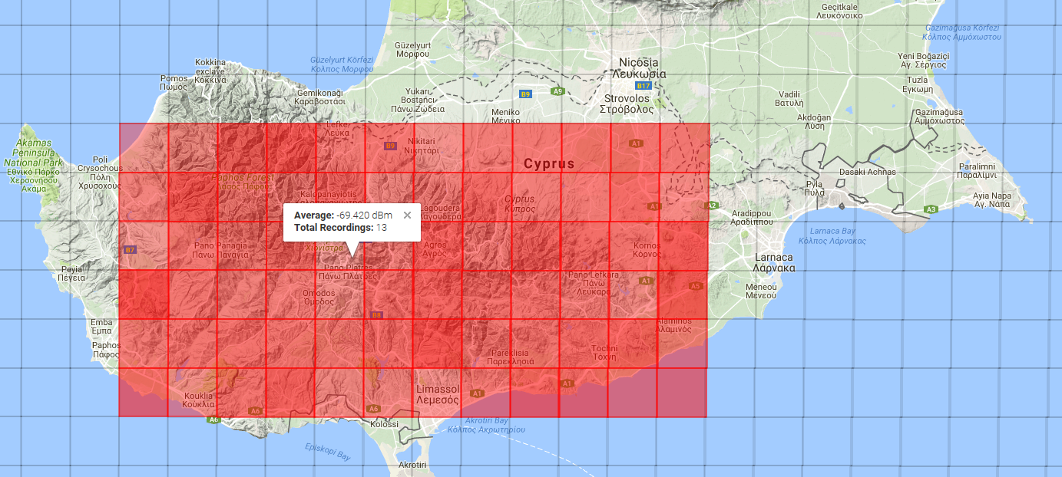

See this site for example how to create the red square

<http://st009194.northeurope.cloudapp.azure.com/CrODA-Gator/>

1. So, when the user chooses the sensor who need create the colourfully square for the database measurements, after that choose the source and destination node and make the root with pins in the map where there are measurements.
2. After, when create the root in the map, the user has the chance to choose one of the two algorithms A*(A star) ALGORITHM or DFS ([Depth-first search](https://en.wikipedia.org/wiki/Depth-first_search)) and make the optimal path. I need to see the algorithms programmatically and to was working correctly. Something like the picture below.

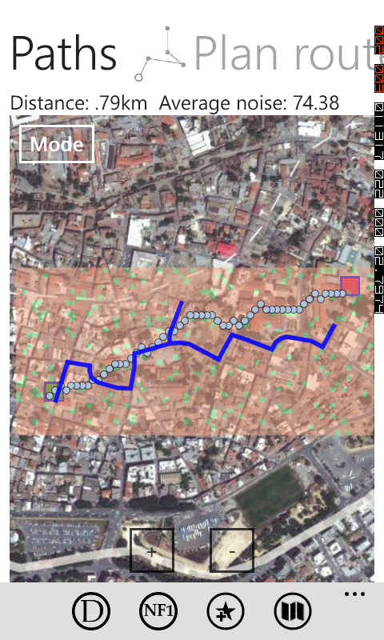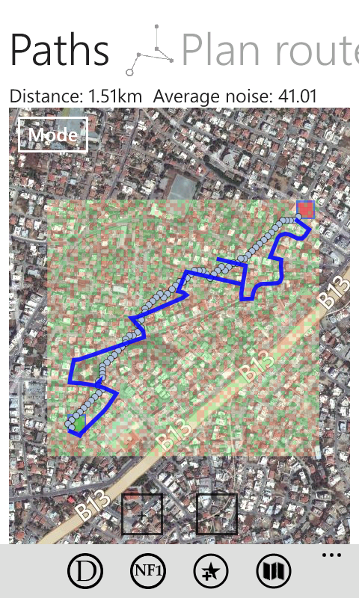

**A* DFS**



1. Two ways for the user to choose the source and destination:
2. The same as it exists -> Please correct the choice : Your location to autocomplete the source destination.
3. When the user put the touch screen create a pins in the map. One pin for the source and one for the destination and autocomplete the boxes for source and destination.

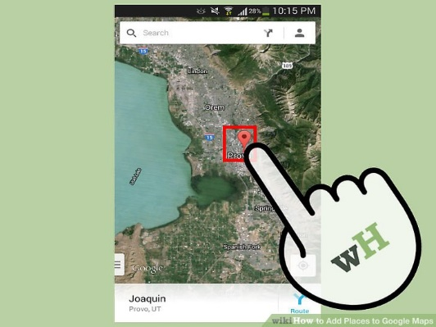

1. I need to see the map in the NORMAL MODE not in Satellite mode.
2. Also, I need to see the root in close in the map when choose the source and destination. Now, needs to touched in the screen to see the root.
3. The favourite button it is not working correctly. The app stops working when I choose one of the favourite root.

8. I need the Records button and the plan path button to use and the mobile data for working not only the wifi.